**Reply from Agitar team:**

Do you mean that if you repeatedly run the same test, sometimes it completes successfully and sometime you get the AnnotationFormatError?  Does the stack trace always appear to be the same?  The original trace you kindly provided was as follows

It is unfortunate that the AnnotationFormatError does not make any reference to which class it was trying to process at the time that the error occurred.  However, perhaps we can work that out by looking at the code in more detail.  We may need to provide some debug versions of the Agitar code to try and resolve this.

**These results are latest one**

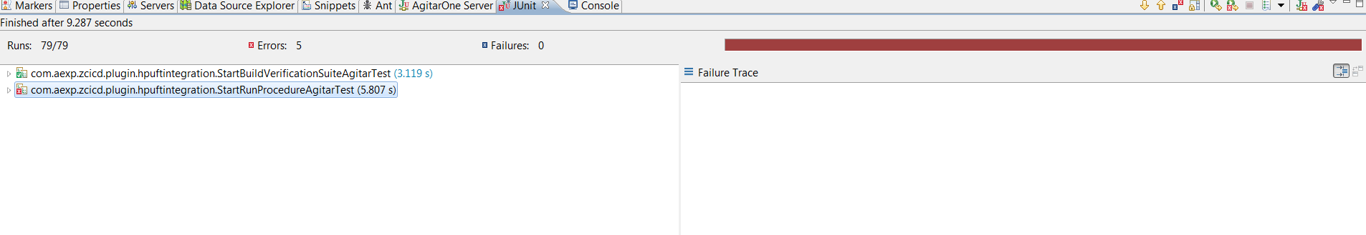

Stack trace 1:

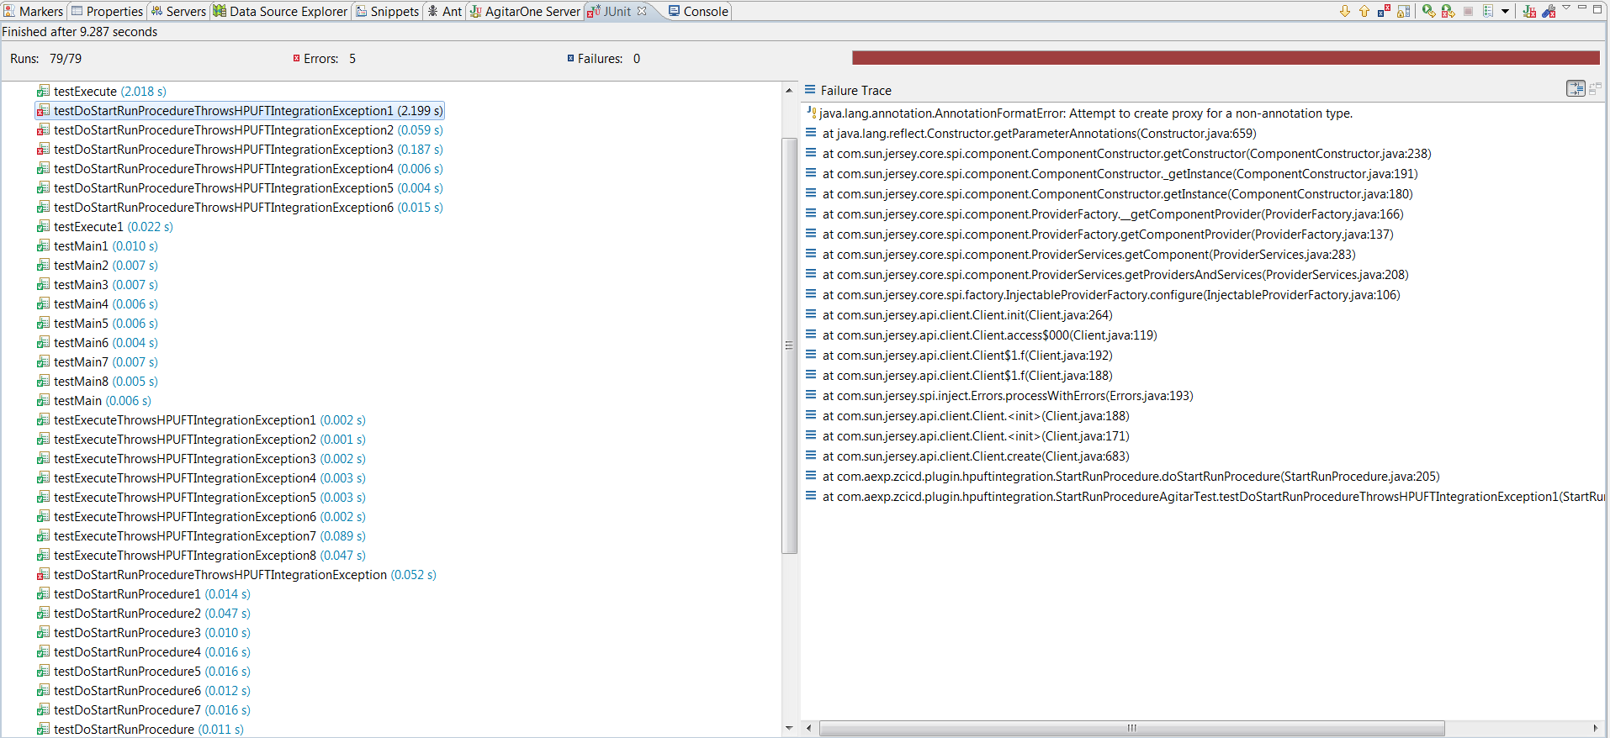

Stack trace 2:

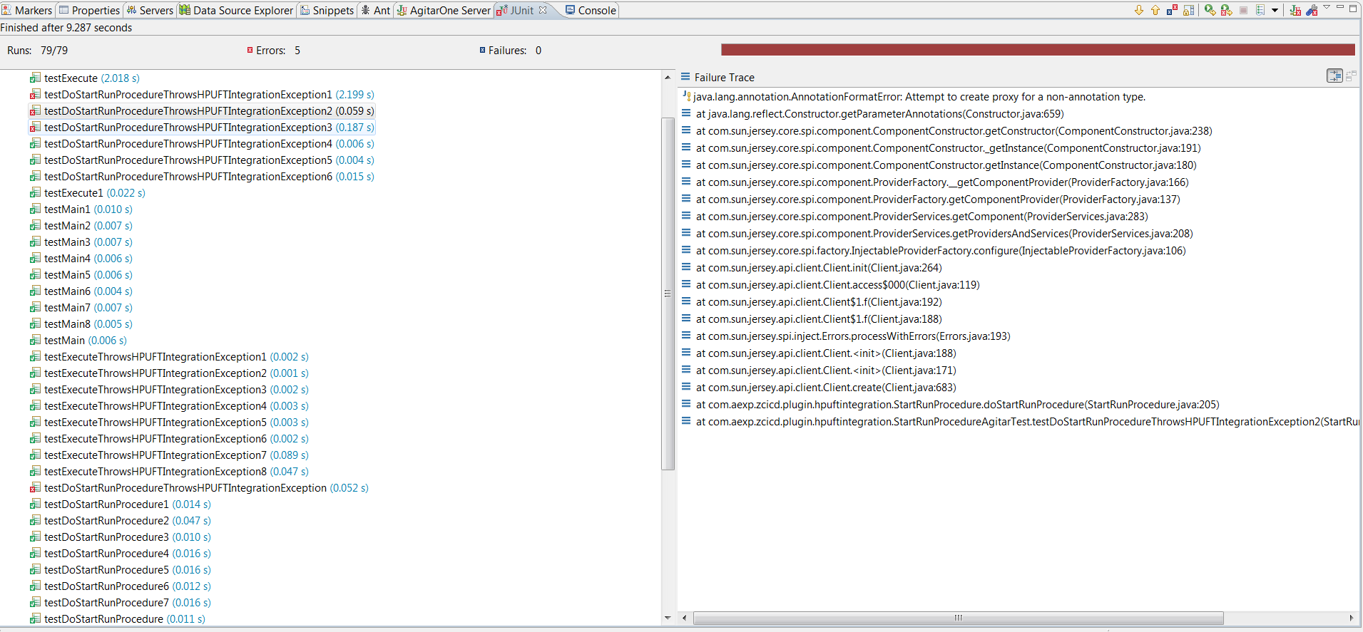

Stack trace 3:

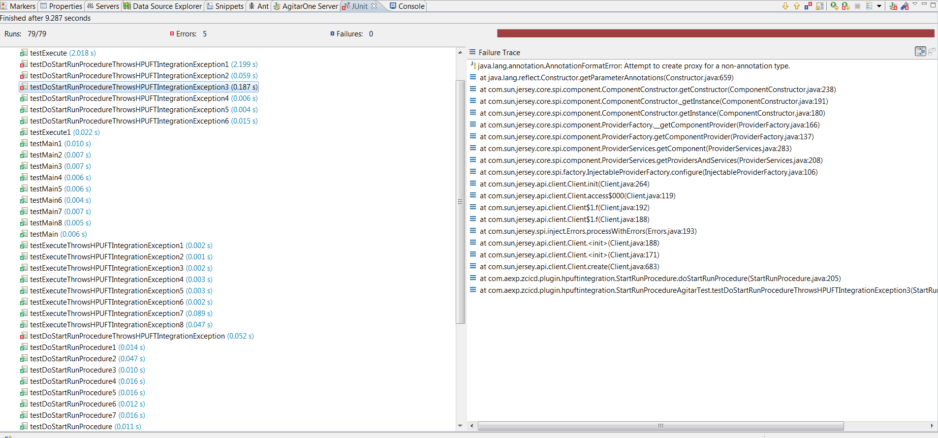

Stack trace 4:

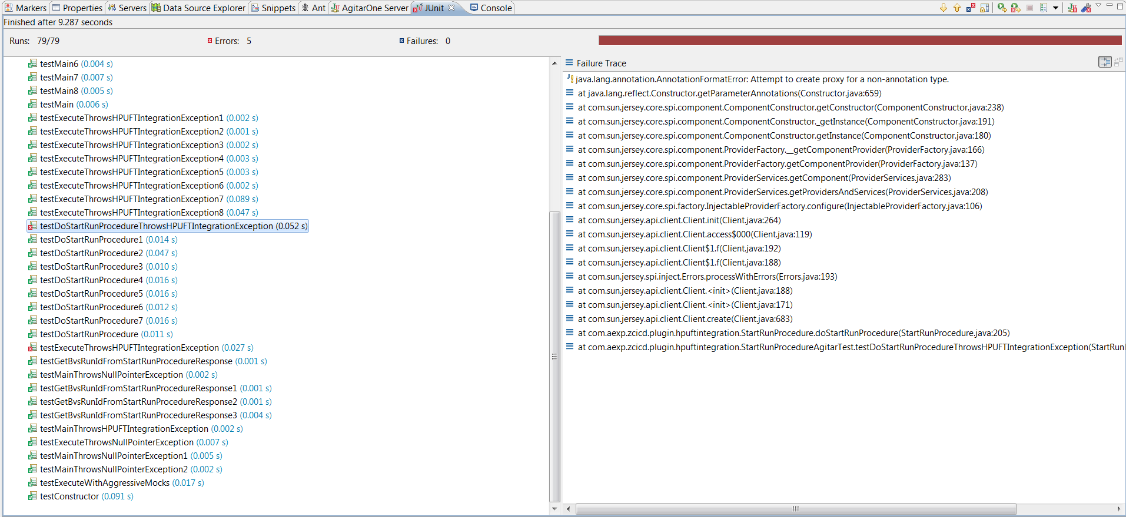

Stack trace 5:

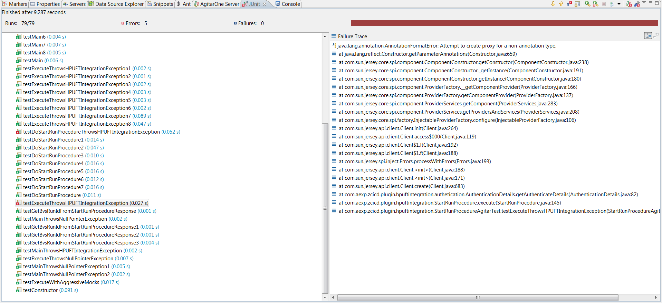

**My observations:**

I tried to generate test cases multiple times with no code change in class

1. StatRunProcedure
2. StartBuildVerificationSuite

These are the two classes which I am trying to generate test cases

**StartRunProcedure:**

In this case it passes all the test cases with no error

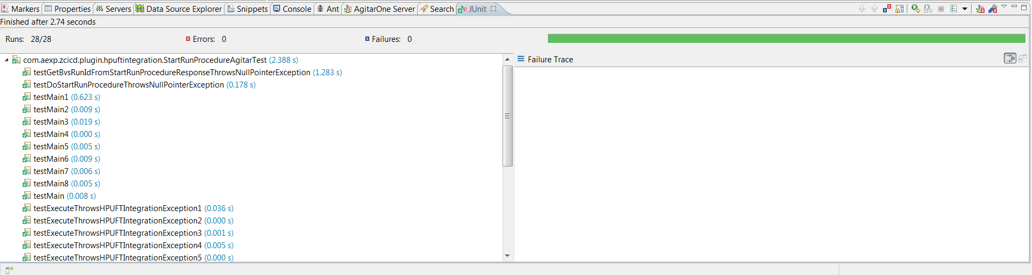

With the same class when I try to generate test cases it gives error

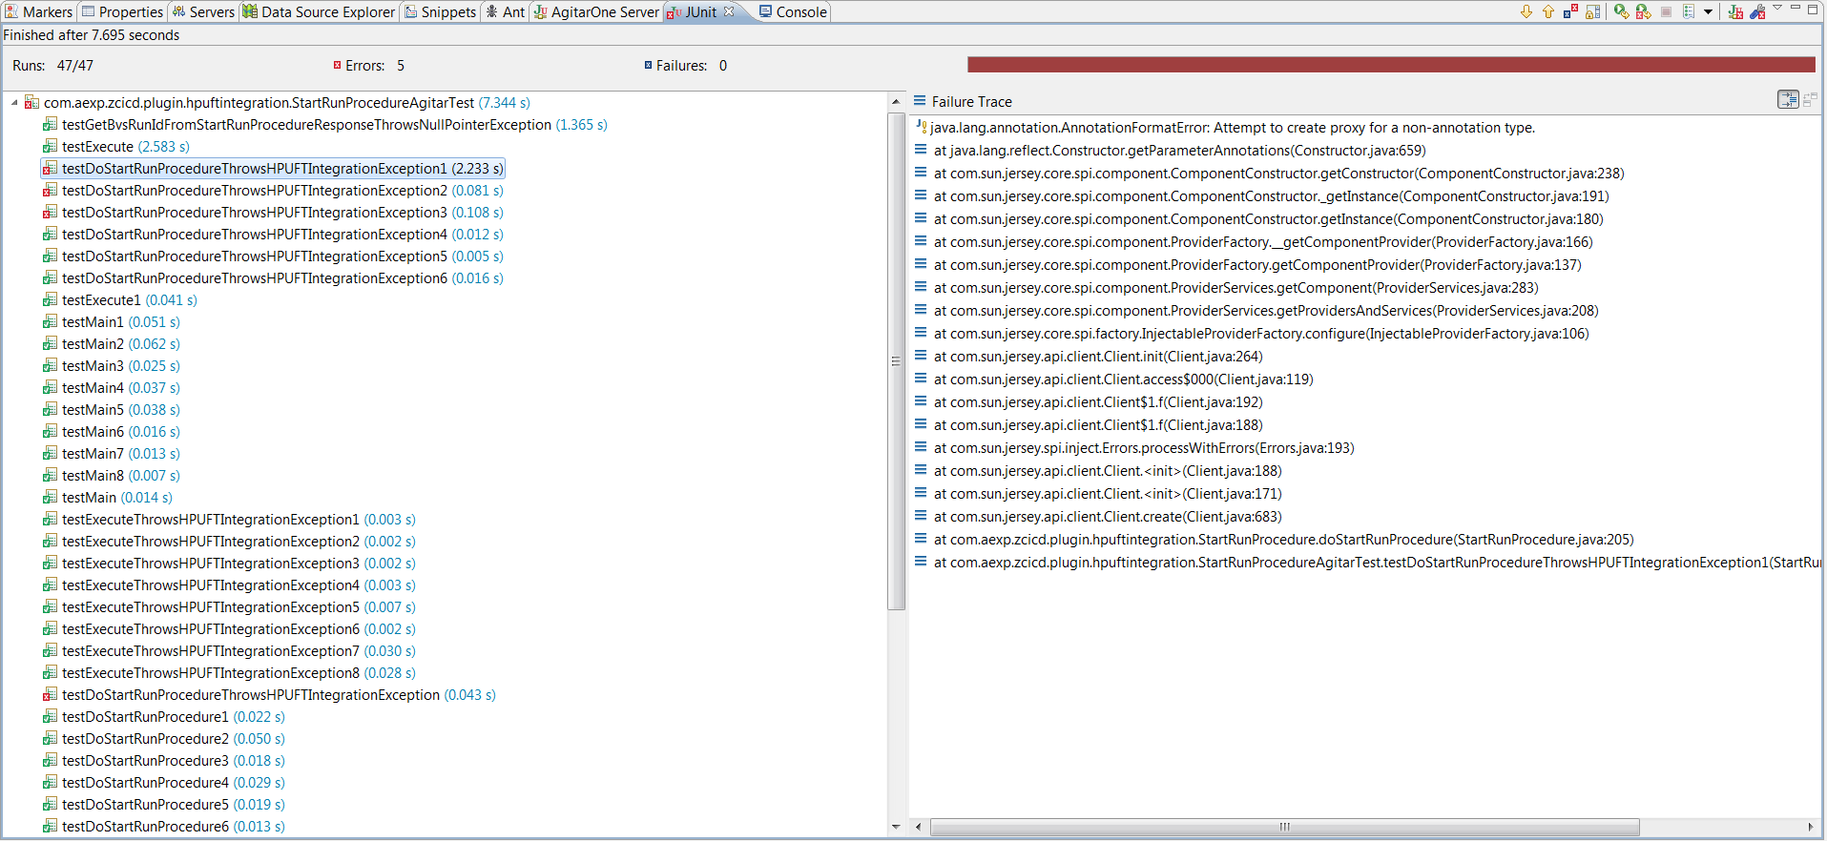

**StartBuildVerificationSuite:**

In this set of test cases it passes all of them

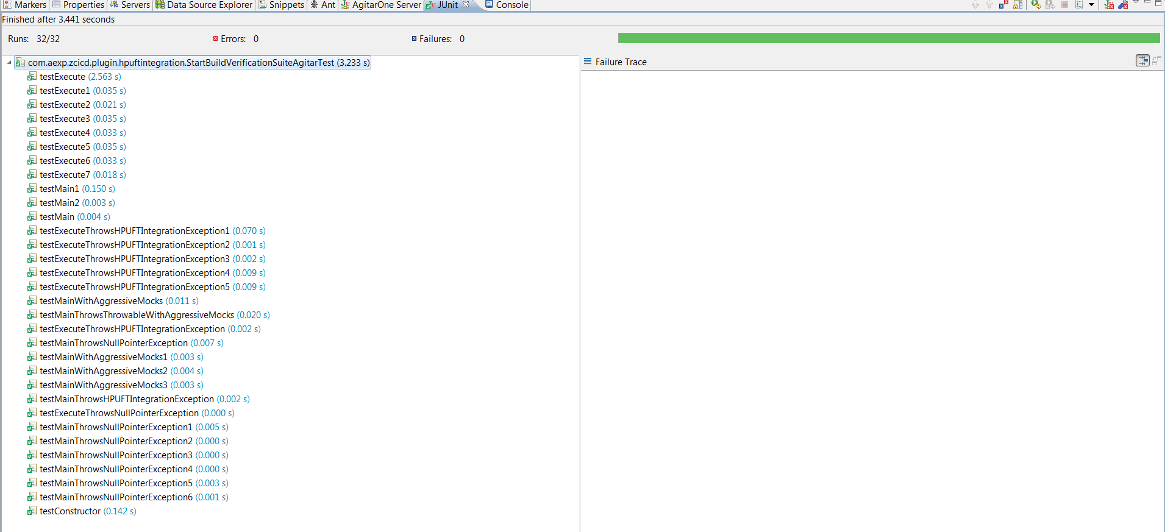

When I tried to generate test cases for the same class with no code change it gives error like this

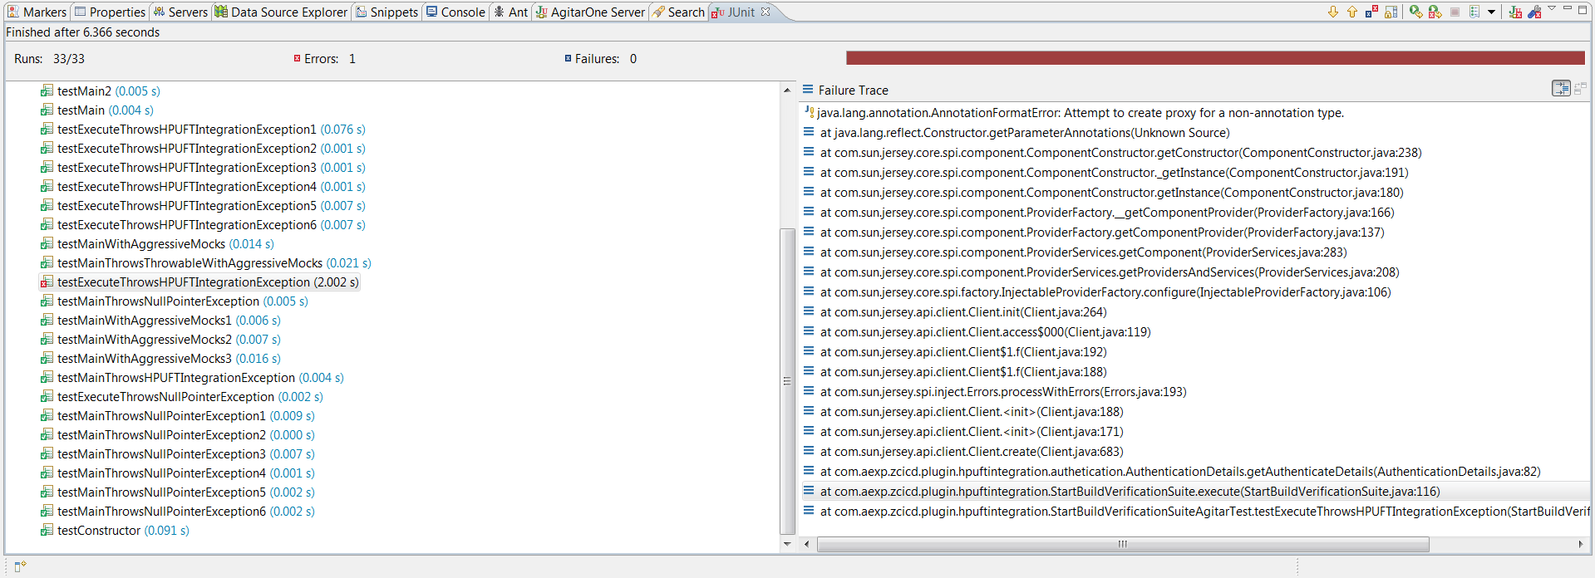

**Summary:**

I am unable to find root cause for this error. The error is not stagnate it occurs at different levels. Sometimes it occur at one method but sometimes it may occur at different method.

Please suggest me a way to solve this error.